Lab - Remote Desktop in Windows 7 and Vista

Introduction
In this lab, you will remotely connect to another Windows 7 or Vista computer.

Recommended Equipment
The following equipment is required for this exercise:
- Two Windows 7 or Vista PCs connected to a LAN.
- The two computers must be part of the same Workgroup and on the same subnet.
  - Enable Remote Desktop Connections on PC 2.
    - Log on to PC 2 as a member of the administrator group. Ask your instructor for the user name and password.
Note: The user account must have a password to access PC 2 remotely.
    - Click Control Panel > System > Remote settings.
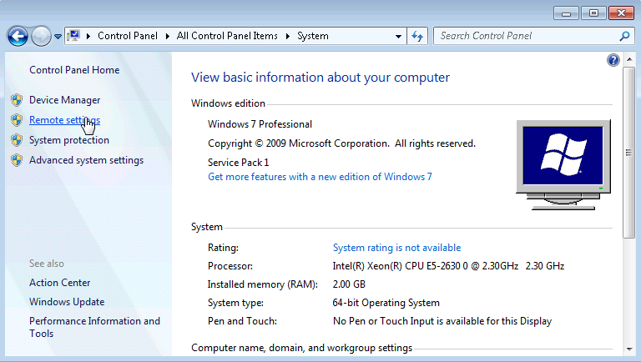
    - In the Remote Desktop area of the System Properties window, select Allow connections only from computers running Remote Desktop with Network Level Authentication (more secure).
    - If a warning message opens indicating that the computer is set to go to sleep, click the Power Options link.
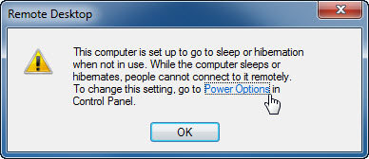
    - The Select a power plan screen opens. Click Change plan setting, and then select Never in the Turn off the display and Put the computer to sleep dropdown boxes. Click Save changes.
Note: If you cannot change the settings, you may need to click Change settings that are currently unavailable to allow you to edit the settings.
Note: This screen can also be opened by clicking Control Panel > Power Options > Change when the computer sleeps.
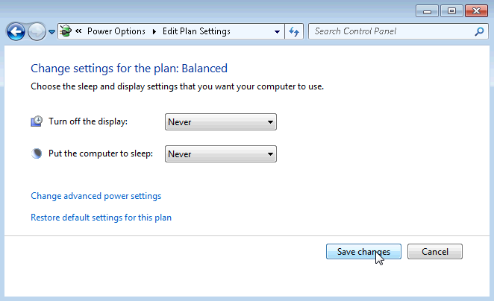
    - Click OK to close the warning message, if it appears.
    - In the System Properties window, click Select Users.
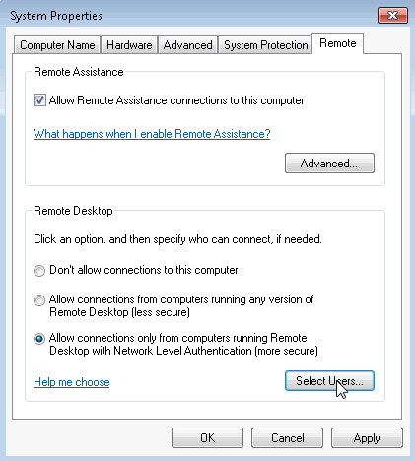
    - The Remote Desktop Users window opens.
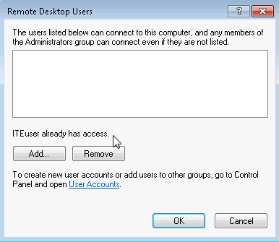
Which user already has remote access?
____________________________________________________________________________________
    - Because you will use this account to gain remote access, you do not need to add any users, click Cancel.
    - Click OK to apply changes and close the System Properties window.
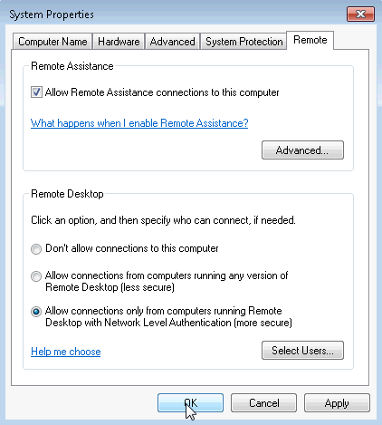
  - Check the firewall settings on PC 2.
    - Click Control Panel > Windows Firewall > Turn Windows Firewall on or off.
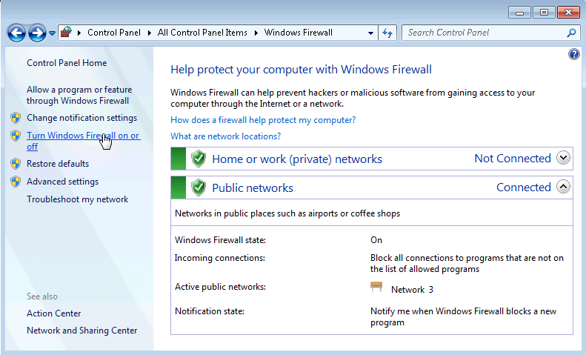
    - Verify that the Turn on Windows Firewall radio buttons are selected for both private and public networks. If they are not, then select Turn on Windows Firewall, and then click OK.
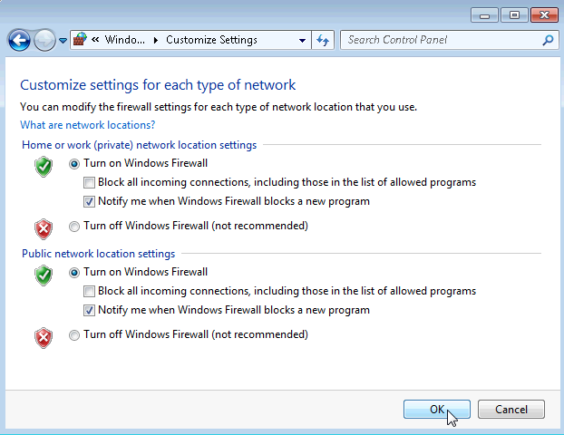
Note: Windows Vista only has the option to turn on or off the firewall. Verify that the On (recommended) radio button is selected.
  - Determine PC 2’s IPv4 Address.
    - Click Start, and then type command prompt and press Enter to open the Command Prompt window.
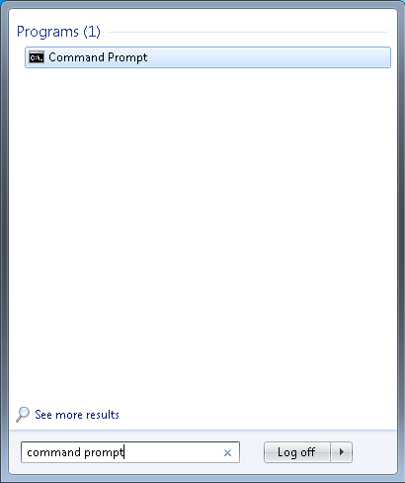
    - From the Command Prompt window, type ipconfig at the command prompt and then press Enter.
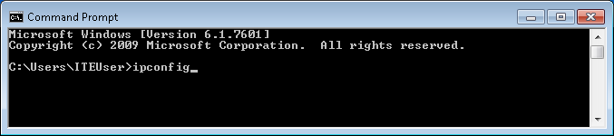
    - You will need PC 2’s IPv4 Address to complete Step 4. The address can be located in the output generated from the ipconfig command. Under the Ethernet adapter Local Area Connection heading, and to the right of the IPv4 Address row.
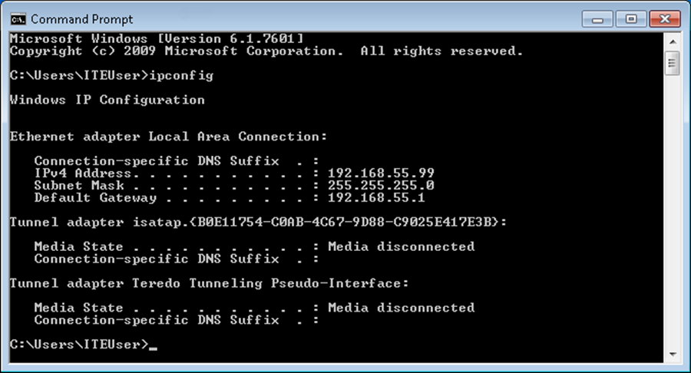
What is PC 2’s IPv4 Address?
____________________________________________________________________________________
    - Close all open windows and log off PC 2.
  - From PC 1, use the Remote Desktop Connection to remotely access PC 2.
    - Log on to PC 1 as an administrator or a member of the administrator group. Ask your instructor for the user name and password.
    - Click Start > All Programs > Accessories > Remote Desktop Connection.
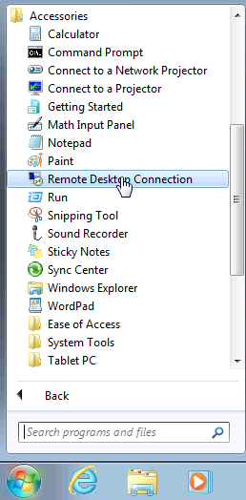
    - The Remote Desktop Connection window opens. Type PC 2’s IPv4 Address into the Computer field and then click Connect.
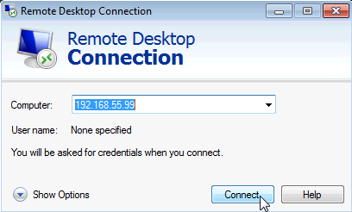
    - The Windows Security window opens. Enter the same user name and password that you used to login to PC 2 in Step 1. Click OK.
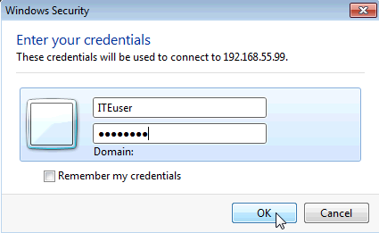
    - Click Yes to allow the connection.
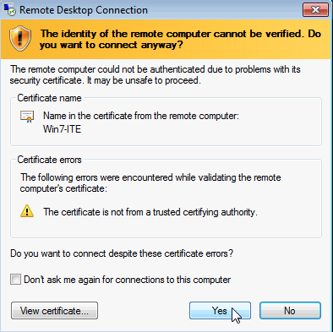
    - The desktop changes and a bar appears at the top of the screen with the IPv4 Address of PC 2.
What does this bar at the top of the desktop indicate?
____________________________________________________________________________________
  - Verify that you are remotely connected to PC 2.
    - Click Start and then type command prompt to open a Command Prompt window.
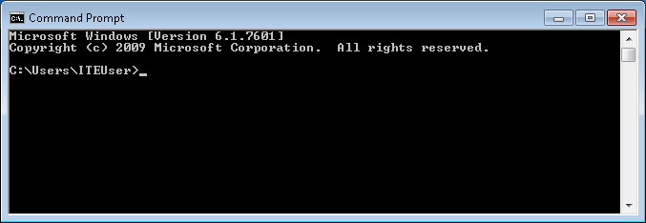
    - Type ipconfig at the command prompt and press Enter to view the PC’s IP Address.

Compare the IP Address that is displayed to PC 2’s IP Address that you wrote down at the end of Step 3.
Are the IP Addresses the same?
____________________________________________________________________________________
    - Click the Minimize button on the Remote Desktop Connection bar at the top of the screen.
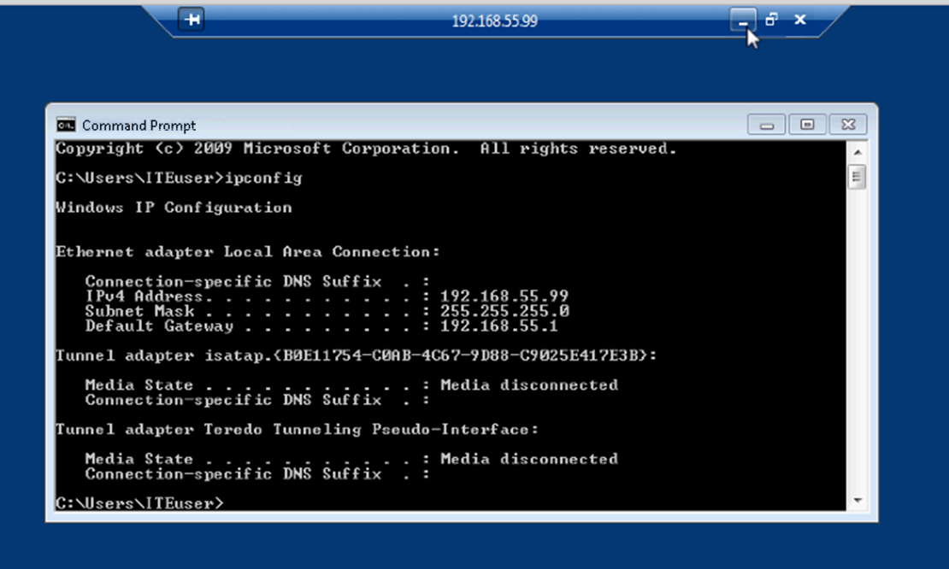
What happens to the desktop?
____________________________________________________________________________________
____________________________________________________________________________________
  - Try to establish a second Remote Desktop Connection to PC 2.
When you connect to a remote PC using RDC and login to that PC with a local username and password, everything works as though you are logging into the PC locally. The problem with that is that only one user can be logged into a Windows PC at a time. That is why logging into a remote Windows PC using RDC will actually log out another RDC or local user.
    - Working from PC 1, with the first RDC session to PC 2 still minimized, click Start > All Programs > Accessories > Remote Desktop Connection.
    - Establish a second RDC session to PC 2 by typing PC 2’s IPv4 Address into the Computer field again, and then clicking Connect.

    - When the Windows Security window opens, enter the user name and password for PC 2 and click OK.

    - Minimize the second session of RDC by clicking the Minimize button on the RDC bar at the top of the screen.

    - Read the Remote Desktop Connection message that appears on PC 1’s desktop, then click OK.
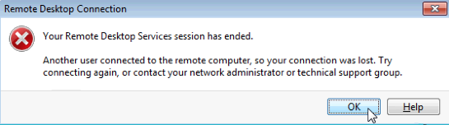
Which RDC session was ended? Why?
____________________________________________________________________________________
____________________________________________________________________________________
____________________________________________________________________________________
    - Maximize your RDC session to PC 2. Click on the RDC icon in the taskbar of PC 1.
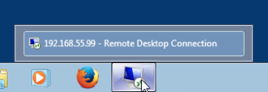
    - You should see the RDC bar displaying PC 2’s IPv4 Address at the top of the screen. Click Start > Log off, to log out of PC 2 and close the RDC session.
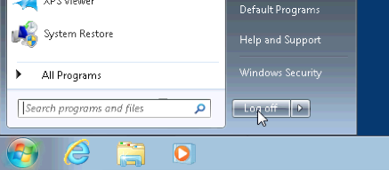
    - Close all remaining open windows on PC 1.

Reflection
  - What happens to a local user signed into PC 2 when a remote user logs into PC 2 using RDC?
_______________________________________________________________________________________
_______________________________________________________________________________________
  - Why would an IT administrator use RDC?
_______________________________________________________________________________________
_______________________________________________________________________________________
_______________________________________________________________________________________

